EXERCISE 1

What are the differences when with or without a microcontroller? Which one is more efficient?

When without a microcontroller, we use variable resistance to control the brightness of LED directedly. From analog signal to digital signal, we only need to change the resistance in the circuit to control the current, which can be shown by the brightness of LED.

When with a microcontroller, the analog signal is as an input of the IC, and the output of IC is a digital signal. So the convert is in the IC itself.

It is more efficient without a microcontroller as the convert need time in IC

EXERCISE 2

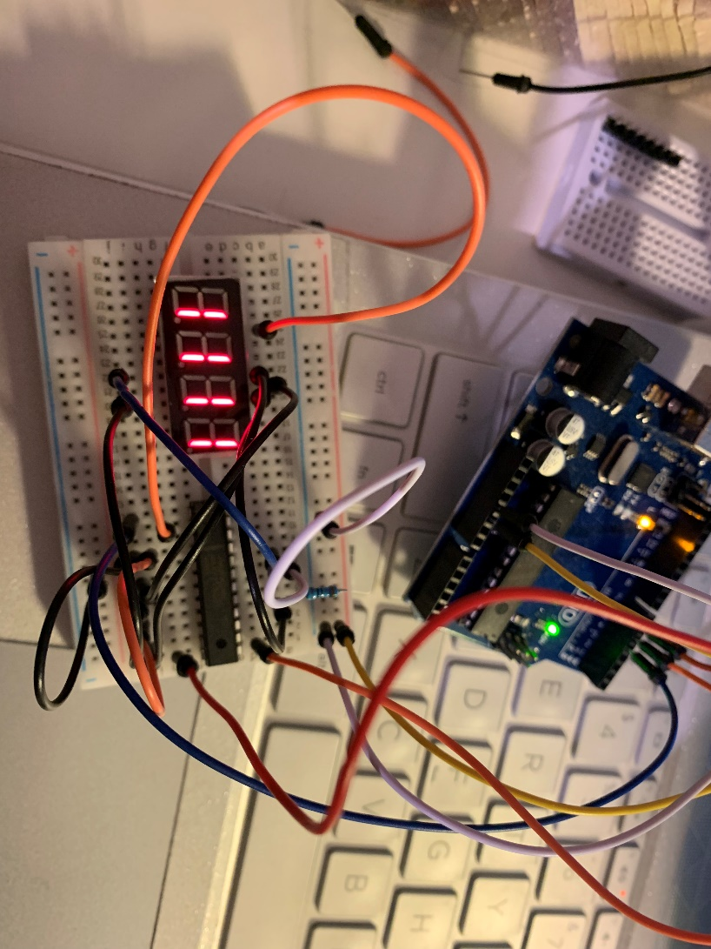

EXERCISE 3

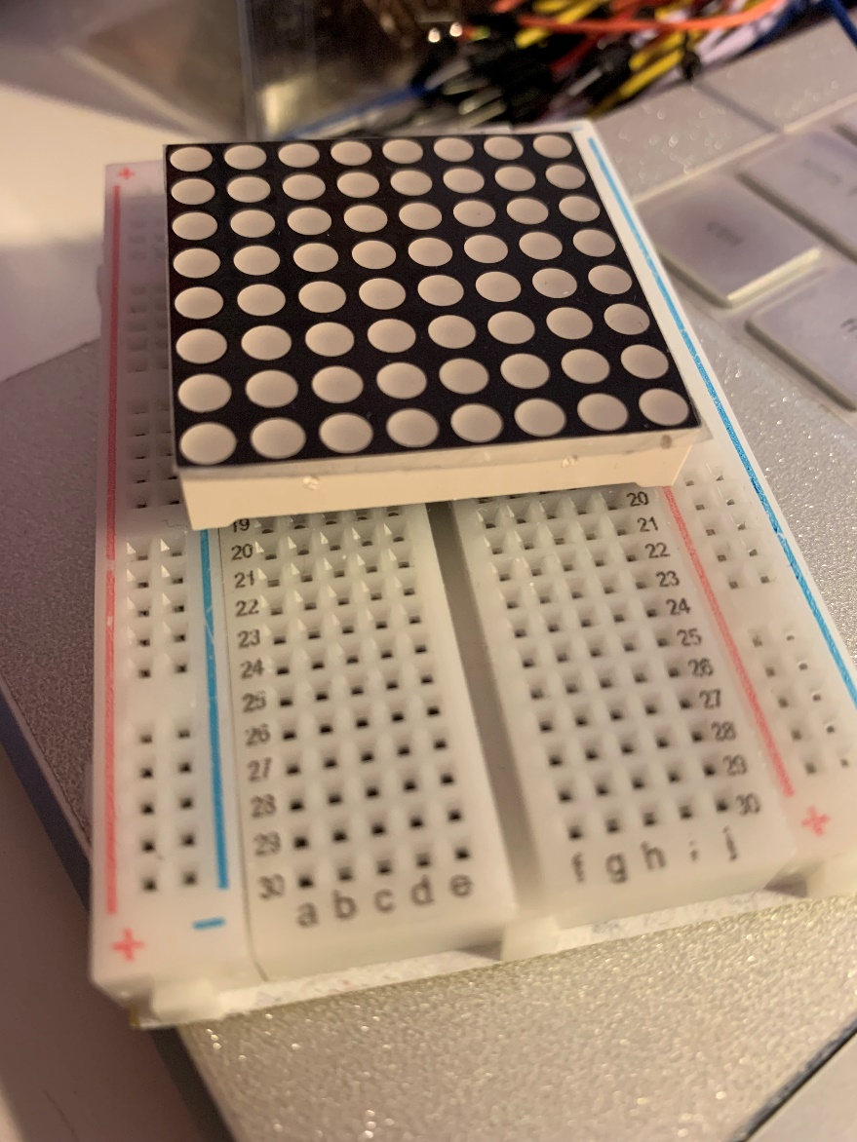

We can not work the LED in the bread board and there is no place to put other wires.

Also, we do not have the exercise 3 link board like this, we don’t know how to do.

If any solutions, please email us. Thank you very much.

